3 marker questions

1. A bank offers 5% of compound interest on half yearly basis. A customer deposits 1600 Rs. each on 1st January and 1st July of the year .At the end of the year the amount he would have gained by the way of interest is?

Ans: 121

1. Six bells commence tolling together and toll at interval of 2, 4, 6, 8, 10 and 12 secs respectively. In 30 minutes, how many times do they toll together?

Ans: 16

1. Two trains running in opposite directions cross a man standing on the platform in 27 secs and 17 secs respectively and they cross each other in 23 secs. The ratio of their speeds is ?

Ans 3:2

1. Along with red bus ticket, you received a complementary ride on the London eye. The giant wheel having radius 10m is rotating .Mass of one cubicle inclusive of the passengers is 300Kg. assuming that the giant wheel has been given a velocity so that it just completes a circle. Determine the amount of force that that the giant wheel having radius 10m is rotating .Mass of one cubicle inclusive of the passengers is 300Kg. Assuming that the giant wheel has been given a velocity so that it just completes a circle. Determine the amount of force that the cubicle will experience at the bottom of the loop( Assume g=10m/s2 and neglect losses due to friction and other external losses.)

ANSWER: 4198.272 N

1. A diesel power station has a fuel consumption of 0.28 kg. The calorific value of fuel is 10,000

Kcal/kg. Determine the overall efficiency.

ANSWER: 30.7%

1. The height of the **Aswan** dam is 364 feet and the length is 3830 feet. Water falls from that height and rotates a turbine of diameter 1m and mass 400 kg. What is the speed of rotation of the turbine

ANSWER: 0.25 rpm

1. The current in the Nile river of Egypt is 1m/s. a swimmer swims 300m downstream and then back to his starting point without stopping. If he can swim 2m/s in still water, find the time of round trip.( in seconds)

ANSWER: 400

1. You are travelling on a motorboat in yellow river

The motorboat is traveling at 4 m/s, East and encounters a current traveling 7.0 m/s, North.

What distance downstream does the boat reach the opposite shore?

Answer: 16.5 m/s

1. You are travelling on a train to Iguazu falls and notice, a man at rest throwing a ball in such a way that it returns to him and the train travels at 58.8m. If the train was travelling with a constant velocity of 14.7m/s on a straight horizontal track .Find the initial speed of the ball as seen from the train.( take g=9.8 and round off to nearest whole number )

ANSWER: 20

1. During your visit to newton Navarro Bridge, you were lucky enough to meet one of the leading marine engineers. He wanted to check your knowledge before a site visit. The following was his question.

Identify the element from the clues given below

1. D block element
2. Corrosion resistant
3. This metal and its alloys oxidises immediately on exposure with air.

Discovered in late 18th century

ANSWER: Titanium

1. Given, in figure, Mass of A= 5kg , Force F= 150 N, Mass of B= ,acceleration of A= , the inclined length = 30 coefficient of friction = 0.5

Find the time taken (in seconds) for B to cover the entire inclined length from 0 to 30m. (round off the answer to suitable whole number)

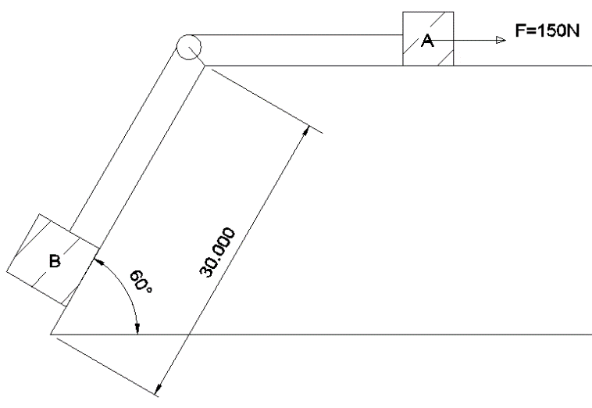

ANSWER: time = 7, 8, 9

1. Walking back to your hotel room from a garden, you notice a fellow traveler suffering from skin irritation and some allergic reactions. You intend to help him out by finding out the cause. He couldn’t speak but had a chemical structure of the compound. Write the common name of the compound.

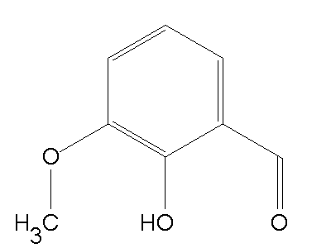

ANSWER: Ortho-vanillin/o-vanillin

1. You are at Princess Towers and you were approached by one of the engineers to help him find out the Moment of inertia about y-y axis. Round off the answer to the nearest whole number.

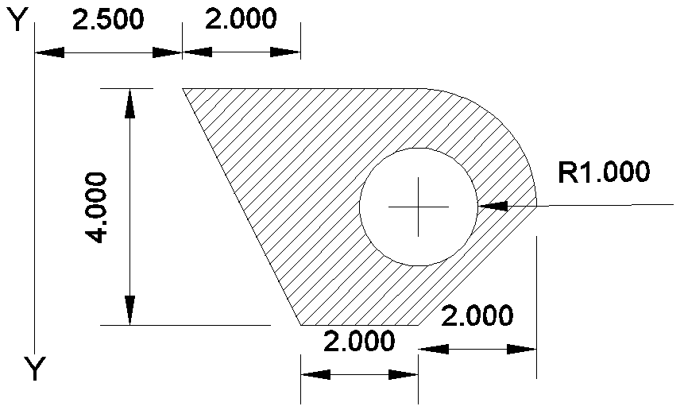

ANSWER: 292,294,296

1. A sphere of relative density of 9 and a diameter of D has a concentric cavity of diameter d. when the sphere just floats on water in a tank, what is the value of D/d (upto 2 decimal places)

ANSWER: 0.96

1. A car starting from rest, accelerates at a rate ‘f’ through a distance ‘S’, then continues at a constant speed for time ‘t’ and then deaccelerates at the rate at the rate ‘f/2’ .to come to rest. If the total distance traversed is ‘5S’. Then how are S and f related?

ANSWER: S= 0.5ft^2

1. A ball of mass 0.2 kg is thrown vertically upwards by applying a force with hands. If the hand moves 0.2 m while applying the force and the ball goes upto 2m height further, find the magnitude of the force. Take g= 10m/s2

ANSWER: 22N

1. A particle A is projected from the ground with an initial velocity of 10m/s at an angle 600 with horizontal. From what height should another particle B be projected horizontally with velocity 5m/s so that both the particles collide in ground at a common point if both are projected simultaneously.

g=10m/s2

ANSWER: 15m

1. An elevator and its load having a total mass of 800kg. The elevator is originally moving downwards at 10m/s, it slows down to stop with constant acceleration in a distance of 25m. What is the tension in the supporting cable while the elevator is being brought to rest?

g=10m/s2

ANSWER: 9600N

1. A dam is situated at a height of 550m above the sea level and supplies water to a power house which is at a height of 50 m above the sea level. 2000kg of water passes through the turbines per second. What would be the maximum power output of the power house (in MW) if the whole system were 80% efficient?

ANSWER: 8

1. A body initially at 800 C cools to 640 C in 5 minutes and to 520 C in 10 minutes. What is the temperature of the surrounding?

ANSWER: 160 C

1. Two spherical bodies A( radius of 6 cm ) and B( radius 18cm) are at temperatures T1 and T2 respectively. The maximum intensity in the emission spectrum of A is at 500nm and in B is 1500nm. Considering them to be black bodies, what will be the ratio of the rate of total energy radiated by A to that of B?

ANSWER: 9

1. Water flows through a capillary tube of radius r and length l at a rate of 40mL per second, when connected to a pressure difference of h cm of water. Another tube of the same length but radius r/2 is connected in series with this tube and the combination is connected to the same pressure head. Calculate the pressure difference across each tube and the rate of flow of water through the combination in mL/s.

ANSWER: 2.353

1. In a laboratory experiment on emission from atomic hydrogen in a discharge tube, only a small number of lines are present in the hydrogen spectrum of a star. What is the reason for this observation?
2. The amount of hydrogen taken is much smaller than that present in the star
3. The temperature of hydrogen in much lesser than that of the star
4. The pressure of the hydrogen is much smaller than that of the star
5. The gravitational pull is much smaller than that in the star

ANSWER: B

1. Two cubes each weighing 22g exactly are taken. One is of iron( d= 8x103 kg/m3)) and other is of marble (d= 38x103 kg/m3). They are immersed in alcohol and then weighed again
2. Iron cube weighs less
3. Iron cube weighs more
4. Both have equal weight
5. Nothing can be said

ANSWER: b

1. Choose the wrong statements
2. The molecules of the liquid lying in the surface film have smaller potential energy in comparison to the inner molecules.
3. For a curved surface of a liquid in equilibrium, the pressure is more on the concave side of the liquid than on the convex side.
4. Excess pressure inside the air bubble of radius R at the depth h inside a liquid of surface tension S is p=h*p*g+ 2*S/R*
5. Angle of contact increases with the increase in temperature of liquid.
6. Angle of contact depends on the inclination of the solid surface to the liquid surface. ANSWER: a,c,e
7. Two resistors having equal resistances are joined in series and a current is passed through the combination. Neglect any variation in resistance as the temperature changes. In a given time interval,
8. Equal amount of thermal energy must be produced in the resistors
9. Unequal amount of thermal energy may be produced
10. The temperature must rise equally in the resistors
11. The temperature may rise equally in the resistors

ANSWER: a and d

1. A gas kept on a container of finite conductivity is suddenly compressed. The process
2. Must be very nearly adiabatic
3. Must be very nearly isothermal
4. May be very nearly adiabatic
5. May be very nearly isothemal

ANSWER: c and d

|  |  |
| --- | --- |
|  | 1. Find the number of triangles in the given figure.   http://www.indiabix.com/_files/images/non-verbal-reasoning/analytical-reasoning/26u.png |
| |  |  | | --- | --- | | [A.](javascript:%20void%200;) | 10 | | [B.](javascript:%20void%200;) | 12 | | [C.](javascript:%20void%200;) | 14 | | [D.](javascript:%20void%200;) | 16 | |

Ans C

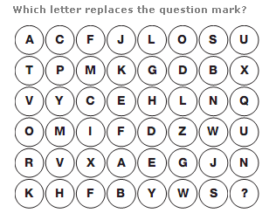

ANSWER: P

1. A guy stole a desktop computer. When he opens it, he finds out that it is password protected. Now, he clicks on the hint and the following appears in front of him:  
     
   1 Jug 2 Birthdays 3 Fights 4 Cars 2 Laptops 1 Watch  
     
   He is left confused entirely. He has no clue. Can you help him with the password?

A: 1st letter of Jug = J  
2nd letter of Birthdays = I  
3rd letter of Fights = G  
4th letter of Cars =S  
ANSWER: JIGSAW

1. Can you complete below number series by replacing "?" with the correct number.  
     
   10 # 10 # 20 # ? # 110 # 300 # 930

***ANSWER***  
45

1. Can you identify the hidden rebus in the image below?  
     
   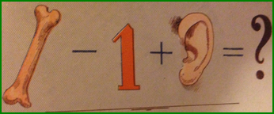  
     
     
     
   ***ANSWER***  
   Bear

|  |
| --- |
| 1. If A + B means A is the mother of B; A - B means A is the brother B; A % B means A is the father of B and A x B means A is the sister of B, which of the following shows that P is the maternal uncle of Q? |
| |  |  | | --- | --- | | [A.](javascript:%20void%200;) | Q - N + M x P | | [B.](javascript:%20void%200;) | P + S x N – Q | | [C.](javascript:%20void%200;) | P - M + N x Q | | [D.](javascript:%20void%200;) | Q - S % P | |

ANSWER: C

|  |
| --- |
| 1. There are 8 houses in a line and in each house only one boy lives with the conditions as given below: 2. Jack is not the neighbour Siman. 3. Harry is just next to the left of Larry. 4. There is at least one to the left of Larry. 5. Paul lives in one of the two houses in the middle. 6. Mike lives in between Paul and Larry.   If at least one lives to the right of Robert and Harry is not between Taud and Larry, then which one of the following statement is not correct ? |
| |  |  | | --- | --- | | [A.](javascript:%20void%200;) | Robert is not at the left end. | | [B.](javascript:%20void%200;) | Robert is in between Simon and Taud. | | [C.](javascript:%20void%200;) | Taud is in between Paul and Jack. | | [D.](javascript:%20void%200;) | There are three persons to the right of Paul. |   Answer: C |

1. Six dice with upper faces erased are as shows.

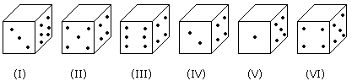

The sum of the numbers of dots on the opposite face is 7.

|  |
| --- |
| If dice (I), (II) and (III) have even number of dots on their bottom faces and the dice (IV), (V) and (VI) have odd number of dots on their top faces, then what would be the difference in the total number of top faces between there two sets? |
| |  |  | | --- | --- | | [A.](javascript:%20void%200;) | 0 | | [B.](javascript:%20void%200;) | 2 | | [C.](javascript:%20void%200;) | 4 | | [D.](javascript:%20void%200;) | 6 |   Answer: D |

1. In a class there are seven students (including boys and girls) A, B, C, D, E, F and G. They sit on three benches I, II and III. Such that at least two students on each bench and at least one girl on each bench. C who is a girl student, does not sit with A, E and D. F the boy student sits with only B. A sits on the bench I with his best friends. G sits on the bench III. E is the brother of C.

|  |  |
| --- | --- |
|  | Which of the following is the group of girls ? |
| |  |  | | --- | --- | | [A.](javascript:%20void%200;) | BAC | | [B.](javascript:%20void%200;) | BFC | | [C.](javascript:%20void%200;) | BCD | | [D.](javascript:%20void%200;) | CDF |   Answer: C |

1. Six flats on a floor in two rows facing North and South are allotted to P, Q, R, S, T and U.

Q gets a North facing flat and is not next to S.

S and U get diagonally opposite flats.

R next to U, gets a south facing flat and T gets North facing flat.

|  |  |
| --- | --- |
|  | Which of the following combination get south facing flats? |
| |  |  | | --- | --- | | [A.](javascript:%20void%200;) | QTS | | [B.](javascript:%20void%200;) | UPT | | [C.](javascript:%20void%200;) | URP | | [D.](javascript:%20void%200;) | Data is inadequate |   Answer: C |

1. In a certain code language $#* means ‘Shirt is clean’, @ D# means ‘Clean and neat’ and @ ? means ‘neat boy’, then what is the code for ‘and’ in that language  
     
   a) #   
   b) D   
   c) @   
   d) Data inadequate   
   Ans: b
2. ‘A man is coded as ‘woman’, woman is coded as ‘girl’, ‘girl’ is coded as ‘boy’, ‘boy’ is coded as ‘worker’ then 6 years female is known as?  
     
   Answer = boy.
3. You are at Burj Khalifa, from that point a building A is at N60E another building B is at S45E and building C is at S40W, Now a building D is at 80 degree anticlockwise to A, 120 degrees clockwise to C and 205 degrees clockwise to B. Find the quarter circle bearing of D.

Consider your location as the origin. (Answer is the following format eg : S79E)

ANSWER: N20W/W70N

1. A body projected vertically from the earth reaches a height Equal to the radius of the earth before returning. The power exerted by the gravitational force is the greatest
2. At the highest point of the body
3. At the instant just before the body hits the earth
4. It remains constant throughout
5. At the instant just after the body is projected

ANSWER: b

1. Calculate the decay energy for the β- decay of 24Na given the following data: m(24Na) = 23.98492 u, m(24Mg) = 23.97845 u, m(24Ne) = 23.98812 u, m(β-) = 5.49x10-4 u. What is the energies (in MeV) of the emitted beta particle?

ANSWER: 5.52

1. A particle is going moving along x-axis. Which of the following statement is false  
   a. At time t1 (dx/dt)t=t1=0,then (d2x/dt2)t=t1=0  
   b. At time t1 (dx/dt)t=t1 < 0 then the particle is directed towards origin  
   c. If the velocity is zero for a time interval, the acceleration is zero at any instant within the time interval.  
   d. At time t1 (d2x/dt2)t=t1 < 0 then the particle is directed towards origin  
     
   ANSWER: B AND C
2. Study the diagram given below and answer each of the following questions.

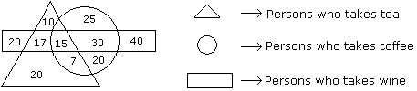

|  |  |
| --- | --- |
|  | How many persons are there who take both tea and coffee but not wine ? |
| |  |  | | --- | --- | | [A.](javascript:%20void%200;) | 22 | | [B.](javascript:%20void%200;) | 17 | | [C.](javascript:%20void%200;) | 7 | | [D.](javascript:%20void%200;) | 20 | |

ANSWER: C

1. Here are some words translated from an artificial language.

morpirquat means birdhouse

beelmorpir means bluebird

beelclak means bluebell

Which word could mean “houseguest”?

* [A.](javascript:%20void(0)) morpirhunde
* [B.](javascript:%20void(0)) beelmoki
* [C.](javascript:%20void(0)) quathunde
* [D.](javascript:%20void(0)) clakquat

ANSWER: C

|  |  |  |
| --- | --- | --- |
| 1. Complete the series     4, 12, 48, 240, 1440, (...) | |  |
|  | |  |
| A. 7620 | B. 10080 |  |
| C. 6200 | D. 10020 |  |

ANSWER: B

|  |
| --- |
| 1. Vincent has a paper route. Each morning, he delivers 37 newspapers to customers in his neighborhood. It takes Vincent 50 minutes to deliver all the papers. If Vincent is sick or has other plans, his friend Thomas, who lives on the same street, will sometimes deliver the papers for him. |
| |  |  | | --- | --- | | [A.](javascript:%20void%200;) | Vincent and Thomas live in the same neighborhood. | | [B.](javascript:%20void%200;) | It takes Thomas more than 50 minutes to deliver the papers. | | [C.](javascript:%20void%200;) | It is dark outside when Vincent begins his deliveries. | | [D.](javascript:%20void%200;) | Thomas would like to have his own paper route. |   Answer: A |

1. A school having 270 students provides facilities for playing four games – Cricket, Football, Tennis and Badminton. There are a few students in the school who do not play any of the four games. It is known that for every student in the school who plays at least N games, there are two students who play at least (N – 1) games, for N = 2, 3 and 4. If the number of students who play all the four games is equal to the number of students who play none, then how many students in the school play exactly two of the four games?

1) 30

2) 60

3) 90

4) 120

ANSWER: 60

1. A sealed capsule containing the radiopharmaceutical phosphorus-32 ( ), an e P32 15 − emitter, is implanted into a patient’s tumor. The average kinetic energy of the beta particles is 700 keV. The initial activity is 5.22 MBq. Determine the energy absorbed during a 10.0-day period. Assume that the beta particles are completely absorbed within the tumor.

ANSWER: 0.4 J

1. How much energy (in MeV) is required to separate the typical middle-mass nucleus 120Sn into its constituent nucleons?

ANS : 1021